Mr. Sheldon Jones Rebecca Freeland
Superintendent of Schools Personnel Director

Richland Parish School System
MENTOR TEACHER APPLICATION

P.O. Box 599 Telephone (318) 728-5964
Rayville, Louisiana 71269 Fax (318) 728-6481

Date__________________________ Social Security No.___________________________

Name: _______________________________________________________________________________
Last First Middle Maiden

Address: _____________________________________________________________________________
Street

______________________________________________________________________________
City State Zip

Telephone: ____________________ Other Telephone: _________________ Cell Phone:______________

Certification: State_____________________ Class (or Type)_______________ Number______________

Areas of Certification: ____________________________________________________________________

General Information
After filing application, candidates for employment may be scheduled to be interviewed by a review committee selected from the school system’s administrators, supervisors and other professional staff members.
Remember to submit a copy of your current teaching certificate and the completed screening activity at the end of this application.
Principals, supervisors and others listed in this application will be contacted for references. If there are references that are not to be contacted, please indicate that supervisor’s name.
Agreement to release of all personnel evaluation results is required to be considered for a mentoring position.
The Richland Parish School System does not discriminate on the basis of race, color, national origin, sex, religion, age or disability in employment or the provision of services. Richland Parish School Board is an equal opportunity employer.
I agree to take the steps necessary to gain a mentor teacher ancillary certificate. (i.e. attend state-approved training and complete the Bloom board distinction process.)

If you agree to the terms outlined above sign here:_____________________________________.

E-mail address:____________________________________________________________________________

Teaching Experience
School  Parish/District | Address  (Please Provide  Complete Address) | Telephone | Principal | Grade or Subject | # of Years | Dates

Are you currently under contract? Yes _______ No _______ If yes, expiration date _____________________
Have you ever been discharged, requested to resign, or refused tenure? Yes ____________ No ______________
If yes, please explain on separate page.
Are you a retiree with the state of Louisiana? Yes_____ No______ If yes, what type of retiree? (Circle One)

Drop retiree Option 5 retiree Service retiree Early Retirement retiree

Professional/Leadership Activities
Professional Organizations, Committees, Presentations, Publications:
__________________________________________________________________________________________
__________________________________________________________________________________________
__________________________________________________________________________________________
__________________________________________________________________________________________

Narrative
Describe why you want to serve as a mentor teacher in Richland Parish.

Mentor Teacher Application Screening Activity

ACTIVITY 1: VIDEO ANALYSIS
Directions: Please watch one of the following video clips (your choice) and answer the questions that follow based on that video. Analyze the needs of the teacher with respect to content instruction. Use a set of data from your observation to diagnose and prioritize the most important needs to address in the mentoring cycle.

Video choices:
Grade 4 ELA: https://youtu.be/eiWuf6x_PgA?si=Q85M64W_Cc1X3x0Z
Grade 5 Math: https://youtu.be/GbBjamdbVbI?si=9c0_2LFP5lkqWQzP
Grade 11 Math: https://youtu.be/HAbxLCQXZ3U?si=pAt-iReoxOp50_bM

Which video did you watch and comment on?

Submit a 300-word narrative that identifies the coaching goals that align to your mentee’s diagnosed needs. Be sure to identify concrete changes in your mentee’s practice that you expect to see as a result of your coaching. Justify the selection of those goals by highlighting the specific evidence you used from your observation in identifying and prioritizing these goals.

Please use the frame below to plan a coaching conversation based on the coaching goals you identified above as if the video clip were of a teacher you were mentoring.

Opening: This is your opportunity to give your teacher 2-3 strengths to continue to use in his or her practice.

Direct Feedback: The teacher should have a clear understanding of the growth area, the skills’ importance, and how it will build student understanding.

Model: Give the teacher a clear picture of the focus skill that he or she can emulate.

Practice: The teacher practices the skill being developed to make it stick.

Next Steps: Define the next steps and make sure the teacher knows what support he or she will be receiving.

ACTIVITY 2: SHORT REFLECTION

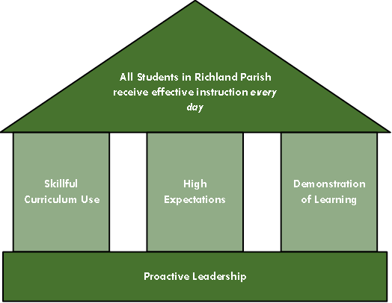

Directions: Please reflect and respond to the following in no more than 300 words: The mission of Richland’s mentoring program is to improve student learning in our schools by continually improving teacher practice. Many students in Louisiana are not proficient in key subject areas like mathematics and reading. What role can Richland’s Instructional framework play in improving K-12 student learning and achievement in the Richland parish?

