Mr. Sheldon Jones Rebecca Freeland
Superintendent of Schools Personnel Director

Richland Parish School System
CONTENT LEADER APPLICATION

P.O. Box 599 Telephone (318) 728-5964
Rayville, Louisiana 71269 Fax (318) 728-6481

Date__________________________ Social Security No.___________________________

Name: _______________________________________________________________________________
Last First Middle Maiden

Address: _____________________________________________________________________________
Street

______________________________________________________________________________
City State Zip

Telephone: ____________________ Other Telephone: _________________ Cell Phone:______________

Certification: State_____________________ Class (or Type)_______________ Number______________

Areas of Certification: ____________________________________________________________________

General Information
After filing an application, all applicants for this leadership positon will then go through a vetting process; all qualifying applicants will be presented to the school system’s principal for final recommendation for leadership.
Remember to submit a copy of your current teaching certificate, a resume, and the completed screening activity at the end of this application.
Principals, supervisors and others listed in this application may be contacted for references.
Agreement to release of all personnel evaluation results is required to be considered for this leadership position.
The Richland Parish School System does not discriminate on the basis of race, color, national origin, sex, religion, age or disability in employment or the provision of services. Richland Parish School Board is an equal opportunity employer.
I agree to take the steps necessary to gain a content leader ancillary certificate. (i.e. attend state-approved training and complete the Bloom board distinction process.)

If you agree to the terms outlined above sign here:___________________________________________________

E-mail:___________________________________________________________________________________

Teaching Experience
School  Parish/District | Address  (Please Provide  Complete Address) | Telephone | Principal | Grade or Subject | # of Years | Dates

Are you currently under contract? Yes _______ No _______ If yes, expiration date _____________________
Have you ever been discharged, requested to resign, or refused tenure? Yes ____________ No ______________
If yes, please explain on separate page.
Are you a retiree with the state of Louisiana? Yes_____ No______ If yes, what type of retiree? (Circle One)

Professional/Leadership Activities
Professional Organizations, Committees, Presentations, Publications:
__________________________________________________________________________________________
__________________________________________________________________________________________
__________________________________________________________________________________________
__________________________________________________________________________________________

Narrative
Describe why you want to serve as a content leader in Richland Parish.

Content Leader Screening

Part 1: CONTENT KNOWLEDGE DEMONSTRATION. Pick one content area activity to submit.

K-2 Literacy and ELA ACTIVITY:
Multiple careful readings of a text from a Tier 1 curriculum are used to make complex grade-level texts accessible to all learners without changing the text. Content leaders need to understand what makes a text complex and how it builds students’ knowledge throughout the unit of study.

Analyze a text that requires multiple reads from a lesson in a Tier 1 Curriculum.
- Select a text that requires multiple, careful reads
  - K-2 Literacy content leader select a text from EL Education
  - ELA content leaders select a text from Guidebooks
- Using the qualitative rubric, determine the complexity of the text. Annotate the rubric with justifications
  - Informational Text
  - Literary Texts
- Use a Reader’s Circle graphic to identify what knowledge and skills you plan to teach with the text.
  - Informational Text
  - Literary Non-fiction Texts
  - Literary Texts

In the space below write a 300 to 500 word narrative that addresses the following:
- How does the text build knowledge and support the end-of-unit/module task?
- What elements of the text require support to make this text accessible to all students in a class?

Math ACTIVITY:
Math content leaders connect deep mathematical content knowledge and understanding of the Louisiana Student Standards for Mathematics (LSSM) to the planning and implementation of Teir 1 math curriculum. Within a Tier 1 math curriculum, math content leaders need to apply their knowledge of the key shifts in the mathematics standards focus, coherence and rigor in order to engage in purposeful, collaborative planning and implement the curriculum with fidelity in a classroom.

Analyze a selected lesson from a Tier 1 math curriculum taught in Richland parish (i.e., Eureka Math²® or Agile Minds) to demonstrate your knowledge of the Key Shifts in mathematics at your preferred grade level.

Through the lens of Focus, Coherence, and Rigor, think through the content of the lesson, the delivery of instruction, and the activities the students will be doing from your selected lesson. Annotate and attach your selected lesson to this application. For annotations, use a colored pen, describing how the Key Shifts in mathematics are illustrated in the selected lesson. Ensure that you focus on how this lesson fits into the scope of learning and specifically which lessons it connects to before, after, and within the unit. Be sure to highlight which levels of rigor are applicable in the lesson you selected.

Science ACTIVITY:
Phenomenon-based instruction centers itself on real-world examples of natural and designed scientific phenomenon and ask student to use critical thinking skills as well as their prior knowledge to determine what causes a phenomenon, as opposed to just learning about the cause. Explaining phenomena allows students to build general science ideas in the context of their application to understanding phenomena in the real world, leading to deeper and more transferable knowledge.

Analyze the first set of 2-5 lessons of from a Tier 1 curriculum unit (i.e., Amplify Science or Inquiry Hub). Use the link below to access the instructional materials.
https://amplify.com/ or https://www.louisianabelieves.com/docs/default-source/year-long-planning/louisiana-guide-to-piloting-inquiryhub-biology.pdf?sfvrsn=59d69d1f_20

What is the anchoring phenomenon of this lesson set?

What will students understand about the anchoring phenomenon by the end of your selected lesson set?

What related phenomena will student engages with throughout this lesson set?

How will exploring each relating phenomena help students progress their understanding of the anchoring phenomenon?

Part 2: SHORT REFLECTION

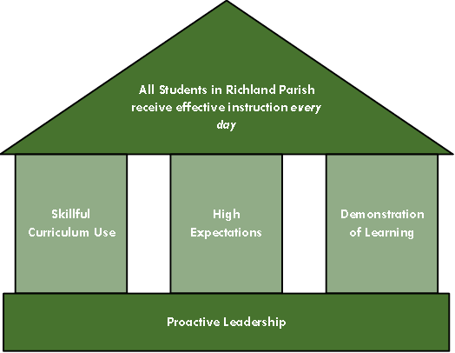

Directions: Please reflect and respond to the following in no more than 300 words. Many students in Louisiana are not proficient in core subject areas. What role can a content leader play in improving K-12 student learning and achievement in Richland Parish? Review Richland Parish’s Instructional Framework and include one to two essential messages that you believe content leaders should communicate to teachers in their building and community at large.

