Name _______________________________ Word Wall Activities – Week Nine
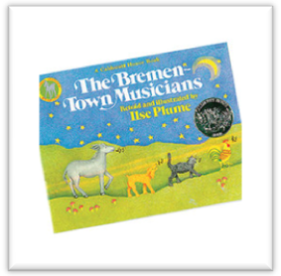
Spelling Words
babies baby lunch lunches note notes
stories story switch switches tune tunes
High-Frequency Words
bought people pleasant probably scared shall sign

Day 1 – Write your spelling words in the correct box.
-s | -ies | -es

Day 2 – Let’s Illustrate
baby | lunch | Skirt | notes | Sign

Day 3 - Define
Lunch: ____________________________________________________________________________________________
Tune: _____________________________________________________________________________________________
Pleasant: __________________________________________________________________________________________
Scared: ____________________________________________________________________________________________
Day 4 – Write spelling words in ABC order.
- ____________ 2. ____________ 3. _____________ 4. ____________
5. ______________ 6. ____________ 7. _____________ 8. ____________
9. ______________ 10. ____________ 11. ____________ 12. ____________

