Name _______________________________ Word Wall Activities – Week 22
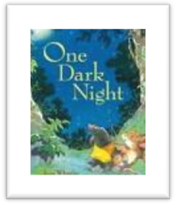
Spelling Words
disagree disappear preheat preschool regroup rerun
retie rewind unlock unpack unplug unsafe
High-Frequency Words
flashes lightening pounds rolling storm thunder pours

Day 1 – Write your spelling words in the correct box.
un- | re- | pre- | dis-

Day 2 – Let’s Illustrate
Unlock | Unpack | Lightening | Storm

Day 3 - Write five sentences and be sure to use a spelling word or high-frequency word in each sentence.

- ___________________________________________________________________________________________
- ___________________________________________________________________________________________
- __________________________________________________________________________________________
- ___________________________________________________________________________________________
- ___________________________________________________________________________________________

Day 4 – Write spelling words in ABC order.
- ____________ 2. ____________ 3. _____________ 4. ____________
5. ______________ 6. ____________ 7. _____________ 8. ____________
9. ______________ 10. ____________ 11. ____________ 12. ____________

