Name _______________________________ Word Wall Activities – Week Twelve
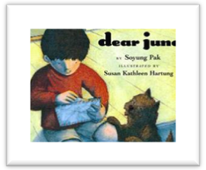
Spelling Words
ago bowl float goat hold most
open show slow toad toast told
High-Frequency Words
answer company faraway parents picture school wash

Day 1 - Write your spelling words.
0 | oa | ow

Day 2 – Let’s illustrate
Float | Toad | Toast | School | Bowl

Day 3 - Write sentences using your high-frequency words.
- ___________________________________________________________________________________________
- ___________________________________________________________________________________________
- ___________________________________________________________________________________________
- ___________________________________________________________________________________________
- ___________________________________________________________________________________________
- ___________________________________________________________________________________________
Day 4 – Write spelling words in ABC order.
- ____________ 2. ____________ 3. _____________ 4. ____________
5. ______________ 6. ____________ 7. _____________ 8. ____________
9. ______________ 10. ____________ 11. ____________ 12. ____________

