Name _______________________________ Word Wall Activities – Week Eleven
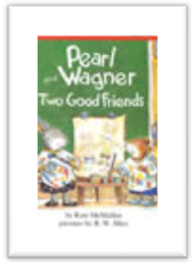
Spelling Words
deep easy feel leave party read
seat sleep team teeth wheel windy
High-Frequency Words
guess pretty science shoe village watch won

Day 1 - Write your spelling words.
e | ee | ea | Y

Day 2 – Let’s Illustrate!
Seat | Sleep | Teeth | Wheel | Shoe

Day 3 - Write sentences using your high-frequency words.
- ___________________________________________________________________________________________
- ___________________________________________________________________________________________
- ___________________________________________________________________________________________
- ___________________________________________________________________________________________
- ___________________________________________________________________________________________
- ___________________________________________________________________________________________
Day 4 – Write spelling words in ABC order.
- ____________ 2. ____________ 3. _____________ 4. ____________
5. ______________ 6. ____________ 7. _____________ 8. ____________
9. ______________ 10. ____________ 11. ____________ 12. ____________

