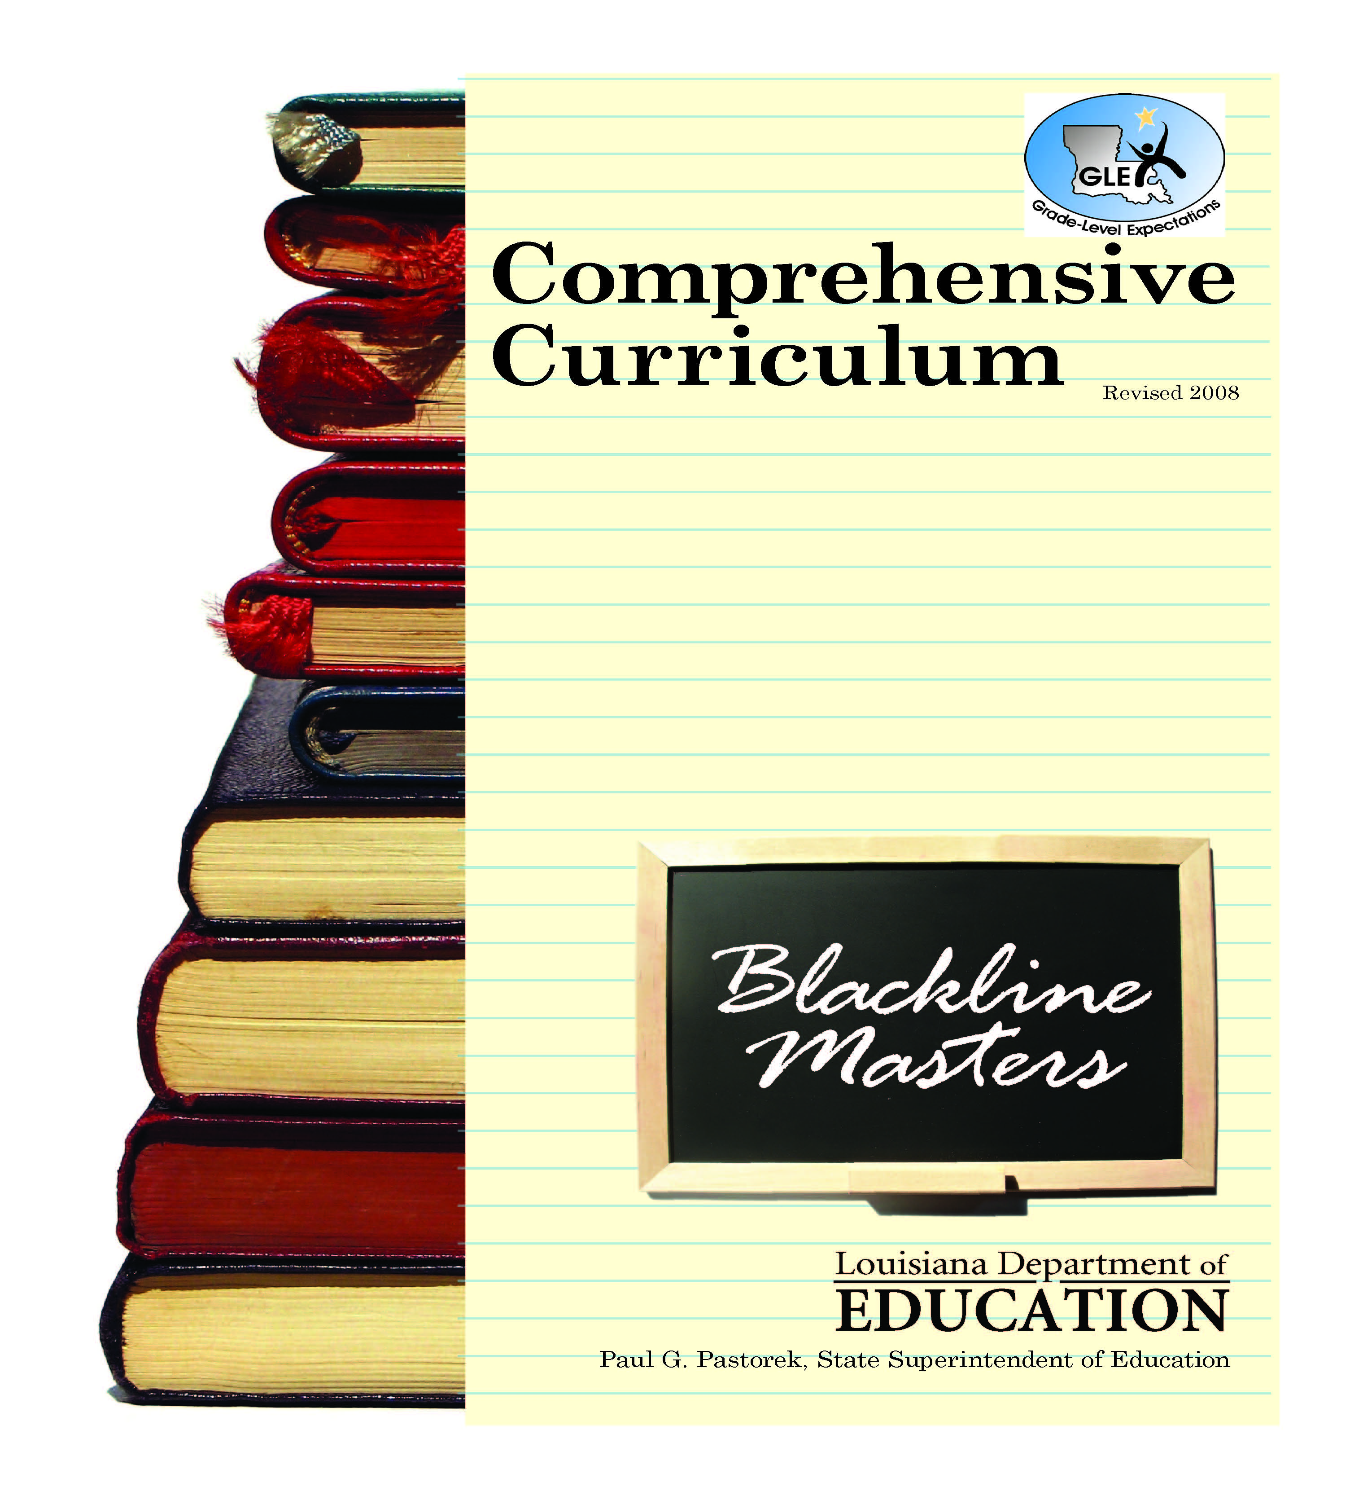
Prekindergarten
Data Collection:
How did you come to school today?
car | bus | walk | bicycle

Data Collection Findings:
Children came to school in a car.

Children came to school in a bus.

Children walked to school.

Children rode a bicycle to school.

More children came to school by:

Fewer children came to school by:

Children at school: Write a numeral on the front of each school house. Use plastic children or people counters for the students to count out for each school house.

Friendship Shape Bracelet: Duplicate shapes on different colors of paper, cut out and give each child all one color. Let children exchange shapes and glue the shapes to strips to make shape bracelets. Variation: You could put children’s photos on shapes or write the first letter of each child’s name on the shapes so when students show their bracelets, they can recall which friend gave them that shape.

How Many Girls and Boys do we have in our class?
girl | boy
Data Collection Findings:
girls are in our classroom

boys are in our classroom

More children in our classroom are

Fewer children in our classroom are

Which hand do you write with?
left hand | right hand
Data Collection Findings:
children write with their left hand.

children write with their right hand.

More children write with their

left hand | right hand

Fewer children write with their
left hand | right hand

Fruit Counter Graph
How many of each type of fruits did you have?

Fruit Kabob Patterns

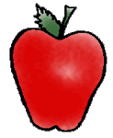

What Kind of Bread Is Your Favorite?

We tasted and graphed our favorite breads. We tasted:

white bread How many? __________
bagels How many? __________
croissants How many? __________

Which bread was liked by the most children? ___________________

Which bread was liked by the fewest children? __________________

We found out: _________________________________________________________

After tasting the apples, which one did you like the best?
red | green | yellow | red and yellow
Data Collection Findings:
Children liked red apples.

Children liked green apples.

Children liked yellow apples.

Children liked yellow and
red apples.

More children liked
red | green | yellow | red and yellow

Fewer children liked
red | green | yellow | red and yellow

